Waleed Khaled Ahmad Sadouq 20160534

Final Internship

**Responsibilities & Problems.**

I was not asked to perform any task related to the work of bank, because the bank does not allow the trainee to interfere with other people's jobs. So I created my own ads without consulting anyone. I designed four ads, the forth ad is brand awareness about the new contract with the Smart buy electric company “I used the closure approach to influence audiences”, and it is the most beautiful advertisement I have designed + The content that I created is better than the content of the advertising company that works for the bank (In the terms of targeting “Considering the behavior of the target market “students”).

**First Advertisement.**

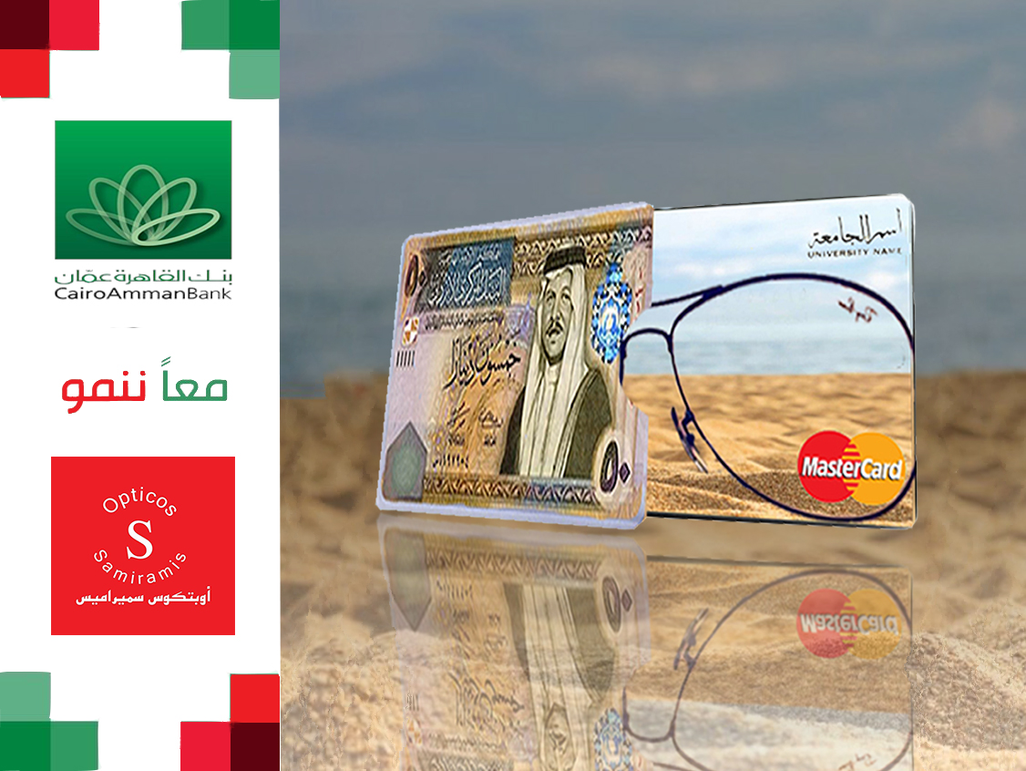

**Second ad**

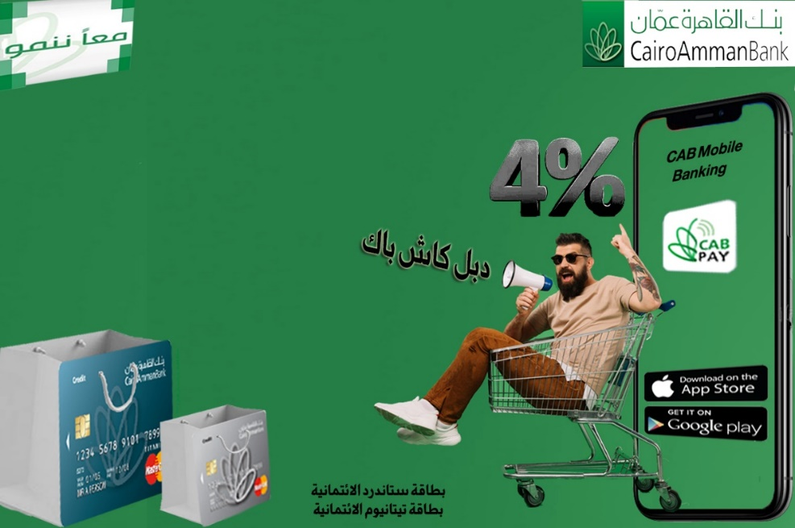

**My Ad**

**Vs**

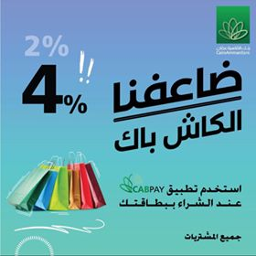

**Agency Advertisment.**

**The Final advertising.**

**My Advertisment.**

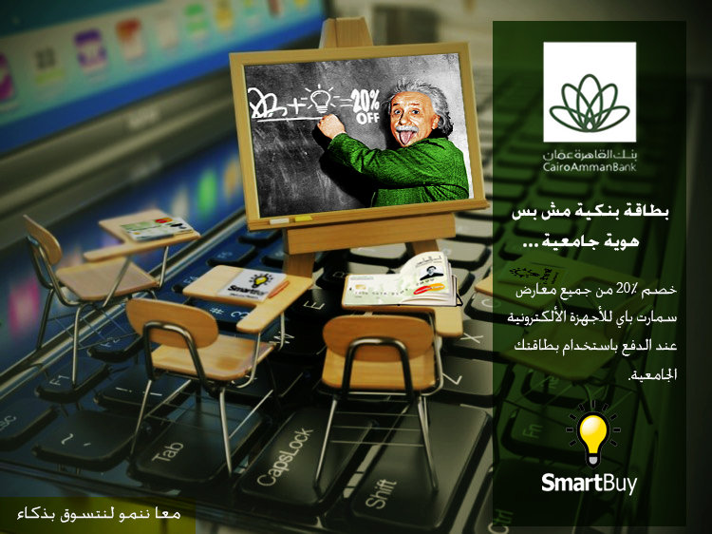

**Vs**

**Agency Advertisement**



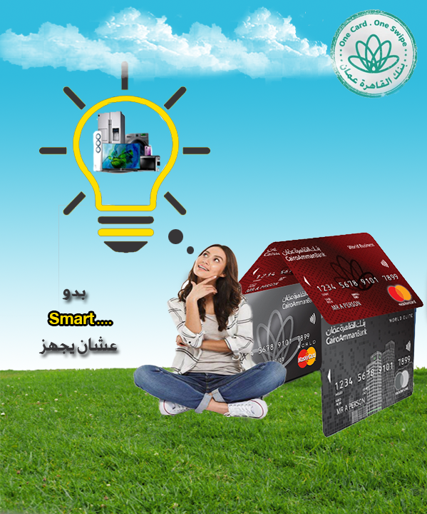

**The third advertisement: The campaign changed from credit cards to university cards.**

**Promotional Plan & Internship Evaluation.**

